10th January 2018

**Spanish presence at DAKAR 2018 with YOKOHAMA and SsangYong**

The legendary Dakar Rally is currently taking place, in its 40th edition and 10th in Latin America. The Dakar will cross Peru, Bolivia and Argentina covering a total of 14 stages between the 6th and 20th of January 2018. Starting in Lima, this year's edition returns to the Pacific Ocean, particularly to the dunes of Peru, which are the protagonist of the first 7 stages. The race will cover more than 5,000 km of rough terrain with the final podium being in the Argentine province of Cordoba for the first time.

As announced at the end of last year the SsangYong Tivoli DKR, a new buggy prototype fully developed and designed in Spain for the sole purpose of defying terrain at the 40th Dakar edition is equipped with the 17” YOKOHAMA Geolandar M / T G003. The YOKOHAMA tyre will be a focal part in the huge challenge in the attempt to overcome the toughest rally in the world.

The Ssangyong Tivoli DKR includes a state of the art multi-tubular chassis of chrome-molybdenum with TIG welding and integrated cage weighing only 240 kilos, it incorporates a powerful V8 engine with 405 hp, located in a rear-central position, and offering a balanced weight distribution between the front and rear axle. With rear wheel drive that is classified in the category T1-3, the Tivoli DKR type and mechanical configuration is the most effective option taking into consideration the route chosen this year in the Dakar, where the sand and the dunes cover a great part of the race.

The Tivoli DKR is driven by Óscar Fuertes from Madrid and his Galician co-driver Diego Vallejo, both with unbeatable experience in rally terrain. The Spanish team has set out with the ambitious goal of concluding the race and doing it among the best debutants, after winning one of the three unique tickets awarded by the organisation with a victory at the Tivoli Rally Raid 4WD in the European Dakar Challenge during the last Baja Aragón Race.

Víctor Manuel Cañizares, Board Member of YOKOHAMA Iberia explained the significant trust placed on YOKOHAMA for this unique challenge and wished the Spanish team every success. Adding, “It is a great opportunity to prove the commitment of our Japanese technology; to be able to witness first-hand the engineering and design that characterises our tyres. Geolandar inspires confidence even in the most brutal terrain”. He added.

The YOKOHAMA Geolandar M/T G003 tyres have a high-density compound with a new triple polymer blend that provides exceptional wear performance. A wide flat profile distributes stresses more evenly across the entire tread area resulting in longer wear. The G003, will be launched into the European Market in Spring 2018.

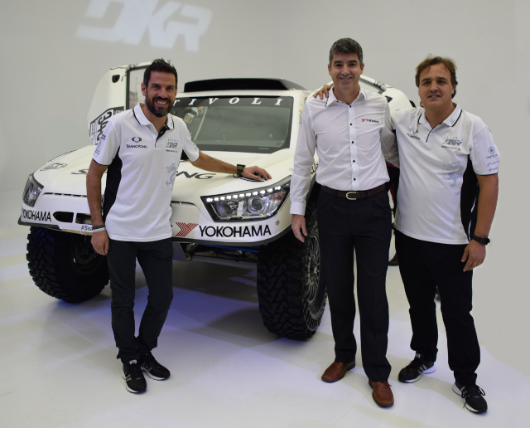

*Tivoli DKR Team with YOKOHAMA Representative in Spain*

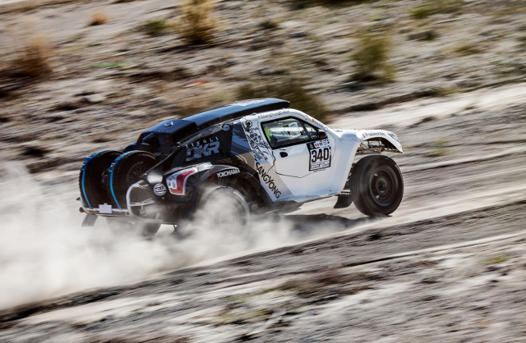

*SsangYong-Tivoli-DKR_13*

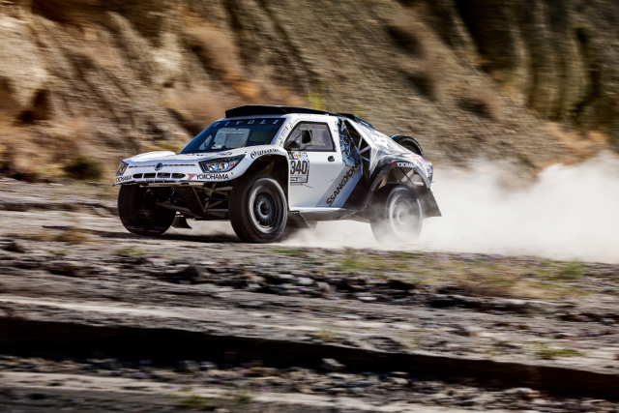

*SsangYong-Tivoli-DKR_16*